Dis-Eur-Iberia-Plaque-Slate-3500-2000-Late Neolithic

**Formal Label:**

**Accession Number:**

**Date or Time Horizon:** 3500-2000 BCE

**Geographical Area:** Southwest Spain

**Cultural Affiliation:** Late Neolithic

**Medium:** Slate

**Dimensions:** H 4.8 cm x W 3.7 cm

**Weight:**

**Provenance:**

**Condition:**

**Discussion:**

SLATE PLAQUE CHALCOLITHIC ANTHROPOMORPHIC IDOL.

Southwest Iberian Bronze Age type. Similar published in the:"Iberian Antiquities from the collection of Leon Levy & Shelby White", Figure 4, page 30.

Size: 4,8 x 3,7 centimeters.

Dated: Twenty to Fifteen Century Before Christ.

**Chalcolithic Ancestral Amulet, sw Iberia, ca 2500 BCE**

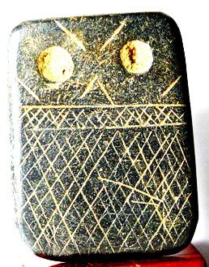

Condition: Excelent, calcareum adhesions cleaned in the anverse.

Provenance: Belgian Collection acquired 1980´s.